
ONLINE SHOPPING SYSTEM

A PROJECT REPORT
Submitted By

SIMRAN SAIFI

(2000290140121)

MUSKAN TOMAR

(2000290140074)

HRITICK VARSHNEY
(2000290140052)

Submitted in partial fulfilment of the
Requirements for the Degree of

MASTER OF COMPUTER APPLICATIONS

Under the Supervision of

Mr. S.D. MISHRA
Supervisor

Submitted to

DEPARTMENT OF COMPUTER APPLICATIONS
KIET Group of Institutions, Ghaziabad
Uttar Pradesh-201206
CERTIFICATE

Certified that Simran Saifi (2000290140121), Muskan Tomar (2000290140074) and Hritick Varshney (2000290140052) have carried out the project work having “Online shopping system” for Master of Computer Applications from Dr. A.P.J. Abdul Kalam Technical University (AKTU) (formerly UPTU), Technical University, Lucknow under my supervision. The project report embodies original work, and studies are carried out by the student himself/herself and the contents of the project report do not form the basis for the award of any other degree to the candidate or to anybody else from this or any other University/Institution.

Date:25 May 2022

Simran Saifi (2000290140121)

Muskan Tomar (2000290140074)

Hritick Varshney (2000290140052)

This is to certify that the above statement made by the candidate is correct to the best of my knowledge.

Date:25 May 2022

S.D. Mishra
Supervisor
Department of Computer Applications
KIET Group of Institutions, Ghaziabad

Signature of Internal Examiner Signature of External Examiner

Dr. Ajay Shrivastava
Head, Department of Computer Applications
KIET Group of Institutions, Ghaziabad
ACKNOWLEDGEMENTS

Success in life is never attained single handedly. My deepest gratitude goes to my thesis supervisor, SD Mishra for his guidance, help and encouragement throughout my research work. Their enlightening ideas, comments, and suggestions.

Words are not enough to express my gratitude to Dr. Ajay Kumar Shrivastava, Professor and Head, Department of Computer Applications, for his insightful comments and administrative help at various occasions.

Fortunately, I have many understanding friends, who have helped me a lot on many critical conditions. Finally, my sincere thanks go to my family members and all those who have directly and indirectly

provided me moral support and other kind of help. Without their support, completion of this work wouldnot have been possible in time. They keep my life filled with enjoyment and happiness.

Simran saifi (2000290140121)

Muskan Tomar (2000290140074)

Hritick Varshney (2000290140052)

4

ABSTRACT

An online shopping system that permits a customer to submit online orders for items and/or services from a store that serves both walk-in customers and online customers. The online shopping system presents an online display of an order cut off time and an associated delivery window for items selected by the customer. The system accepts the customer's submission of a purchase order for the item in response to a time of submission being before the order cut off time. The online shopping system does not settle with a credit supplier of the customer until the item selected by the customer is picked from inventory but before it is delivered. Therefore, the customer can go online and make changes to the order. In addition, available service windows are presented to the customer as a function of customer selected order and service types and further, the order picking is assigned in accordance with a picker's preference. When ordering goods, many shopping systems provide a virtual shopping cart for holding items selected for purchase. Successive items selected for purchase are placed into the virtual shopping cart until a customer completes their shopping trip. Virtual shopping carts may be examined at any time, and their contents can be edited or deleted at the option of the customer. Once the customer decides to submit a purchase order, the customer may print the contents of the virtual shopping basket in order to obtain a hard copy record of the transaction.

5

Table of Contents

Candidates Declaration…………………………………………………………

Acknowledgement…………………………………………………………….…

List of Figures……………………………………………………………………

List of Abbreviations……………………………………………………………

List of Table……………………………………………………………………...

List of Figures……………………………………………………………………

Abstract………………………………………………………………………..…

1. Introduction 8-16

Objective 8

Scope 8

Methodology 8

2. Background & Literature Survey… 16-20

Literature Review 16-18

Requirement Specification. 18-20

3. Design… 21-22

Class Diagram… 21

Flow Diagram 22

4. Technology & Tools Used… 22-23

Front-end Tools… 22

Back-end Tools… 23

Operating System 23

Additional Software Requirement (Web Browser) 23

5. Hardware Requirement… 24

System Configuration (CPU, RAM, HDD) 24

6. Source Code 24-36

Front End Code… 24-25

Back End Code… 26-36

7. Snapshots 36-49

Data Collection… 36-37

Model Evaluation… 37-38

Methods… 39-45

Conclusion………………………………………………………………………
8. Bibliography. 50

7

- Introduction

1.1. Objective:

- Manage the shopping details: The whole system of online shopping manage the detail of each shopping done by the customers. They extract the product details of what consumers shopped.
- Manage the payment details: In online shopping, customers get many options for mode of payments. Websites give them the option of online payment through debit or credit cards. Customers have also the option of net banking or cash on delivery payment option. It is the objective of an online shopping system to manage all the payment details of each product.
- Generate the information of customers and products: Online shopping system manages the whole information about the customers and the purchased products.
- Reduce the cost of management: Online shopping or digital shopping help in reducing the management cost of products.

  - . Scope:

Shopping cart is one of the important facility provided in online shopping, this lets customer to browse different goods and services and once they select an item to purchase they can place the item in shopping cart, and continue browsing till the final selection. Customers can even remove the items from shopping cart that were selected earlier before they place the final order. It reminds us of shopping basket that we carry in departmental store

1.3. Methodology:

Product information management
The product information management (PIM) module contains all the information related to the products in the e-commerce catalog. Some of the information managed by PIM includes:
SKUs
Title
Descriptions
Attributes
Technical specifications
Images

Shopping cart and checkout

The shopping cart allows customers to select and hold the products they wish to purchase. It tracks the user’s session, allowing them to leave the site and come back later with items still in their cart.
During the checkout process, the cart collects the customer’s payment information. This information is passed to the third-party payment processor. The details of the order are sent to other modules like the order management system (OMS), inventory management system, and customer relationship management (CRM) system.

- Background & Literature Survey

2.1. Literature Review :-

This chapter will mainly discuss on the study that are done by previous research of other authors in the similar area of the present study. Throughout this chapter, there will be comprehensive discussion on theoretical and practical views of previous studies done in online shopping and offline shopping for apparels. This study combines factors that other studies have done that will influence the consumer’s purchasing decision in online and offline stores for apparels. It includes the price attractiveness, time saving, perceived risk, enjoyment and excitement, tangibility and high interactivity. All of these factors will contribute to the study of customer’s purchasing intention for apparels on both stores which includes online and offline shopping. Pan, (2007) defined purchasing intention as the eagerness of purchasing the product. Similarly, Engel, Blackwell and Miniard, (1990) defines purchasing intention as a psychological process of decision-making. In online shopping, it is expected that shoppers are more likely to associate price attractiveness and time saving with their intention to shop while in offline shopping, consumers are more likely to associate tangibility, high interactivity and enjoyment with their intention to shop. As a result, online marketers or retailers should be aware of the problems faced by the consumers and their perceived risk to increase their intention to shop in online.

- Time saving
Time is also perceived as one of a factor that relates with intention to purchase in a shopping context. It is believed that consumers have their own perception of time, whether or not to shop from the internet. According to Hansen and Jensen (2009), accomplishing the shopping trip as soon as possible refers to the time-saving oriented consumers and they prefer store choices favoring quick shopping; people who dislike shopping and approaching for time saving retail stores refers to the economic shoppers or known as “problem-solvers”.

- Perceived risk
Perceived risk is defined as consumer experiencing consequences or the amount of uncertainty in contemplating as particular purchase decision. (Cox and Rich, 1964). Similarly, Gronhaug, (1976); Newall, (1977); Upah, (1980) defined perceived risk as the potential of unfavorable consequences and the level of uncertainty in a purchasing situation. Stone and Gronhaug (1993) defined perceived risk increases psychological costs when feelings of discomfort occur in an individual. According to Walker and Johnson (2006), they stated that perceived risk has two main concerns. First is concerning the service delivery system’s technical performance or functional reliability; and second is concern on privacy and security.

2.2. Requirement Specification

- Introduction

This document is meant to delineate the features of OSS, so as to serve as a guide to the developers on one hand and a software validation document for the prospective client on the other. The Online Shopping System (OSS) for electronics item shop web application is intended to provide complete solutions for vendors as well as customers through a single get way using the internet.It will enable vendors to setup online shops, customer to browse through the shop and purchase them online without having to visit the shop physically. The administration module will enable a system administrator to approve and reject requests for new shops and maintain various lists of shop category.

- Definitions, Acronyms, and Abbreviations –

Definitions:
OSS- Online shopping System (for electronics item shop) SRS- Software Requirement Specification GUI- Graphical User Interface Stackholder- The person who will participate in system Ex. Customer, Administrator, Visitor etc.

- References

Wikipedia: https://www.wikipedia.org/
Tutorials point: https://www.tutorialspoint.com/
Geeks for geeks: https://www.geeksforgeeks.org/

- IEEE Standard 830-1998 a Recommended Practice for Software Requirements Specifications.

18

- Overview

This system provides an easy solution for customers to buy the product without going to the shop and also to shop owner to sale the product. This proposed system can be used by any naïve users and it does not require any educational level, experience or technical expertise in computer field but it will be of good use if user has the good knowledge of how to operate a computer.

Overall Description-

The Online Shopping system (OSS) application enables vendors to set up online shops, customers to browse through the shops, and a system administrator to approve and reject requests for new shops and maintain lists of shop categories. Also the developer is designing an online shopping site to manage the items in the shop and also help customers to purchase them online without visiting the shop physically.The online shopping system will use the internet as the sole method for selling goods to its consumers.

2.1 Product Perspective:

This product aimed toward a person who don’t want to visit the shop as he might don’t get time for that or might not interested in visiting there and dealing with lot of formalities.

Functional Requirements:
This section provides requirement overview of the system. Various functional modules that can be implemented by the system will be –

- Description:
- Registration If customer wants to buy the product then he/she must be registered, unregistered user can’t go to the shopping cart.

- Login Customer logins to the system by entering valid user id and password for the shopping. 3.1.3 Changes to Cart Changes to cart means the customer after login or registration can make order or cancel order of the product from the shopping cart.

- Payment In this system we are dealing the mode of payment by Cash.We will extend this to credit card,debit card etc in the future.

- Logout After ordering or surfing for the product customer has to logout.

- 3.1.6 Report Generation After ordering for the product,the system will sent one copy of the bill to the customer’s Email-address and another one for the system data base.
- NON-FUNCTIONAL REQUIREMENTS:

Following Non-Functional Requirements will be there in the insurance to the internet:
(i) Secure access to consumer’s confidential data.
(ii) 24X7 availability.
(iii) Better component design to get better performance at peak time.
(iv) Flexible service based architecture will be highly desirable for future extension.
Non-Functional Requirements define system properties and constraints. Various other Non-Functional Requirements are:
- Security
- Reliability
- Maintainability
- Portability
- Extensibility
- Reusability
- Compatibility
- Resource Utilization

20

- Design:

- Class Diagram

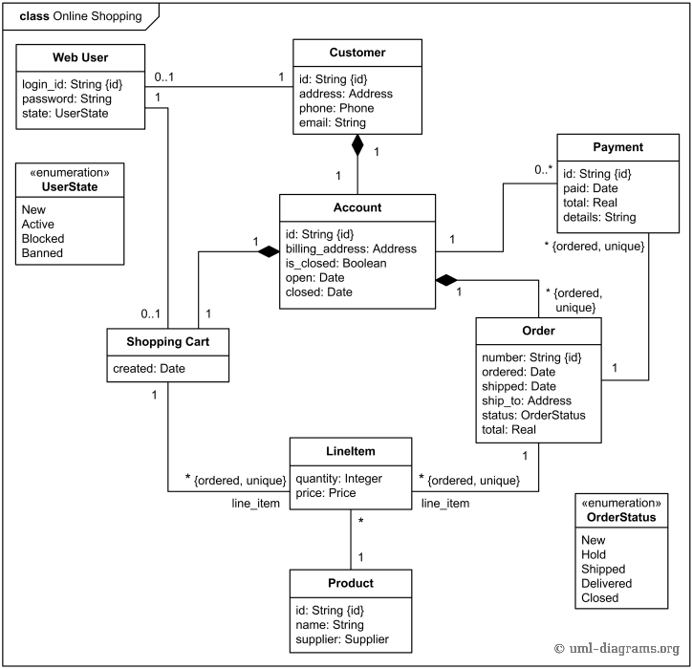

- DFD Diagram:-

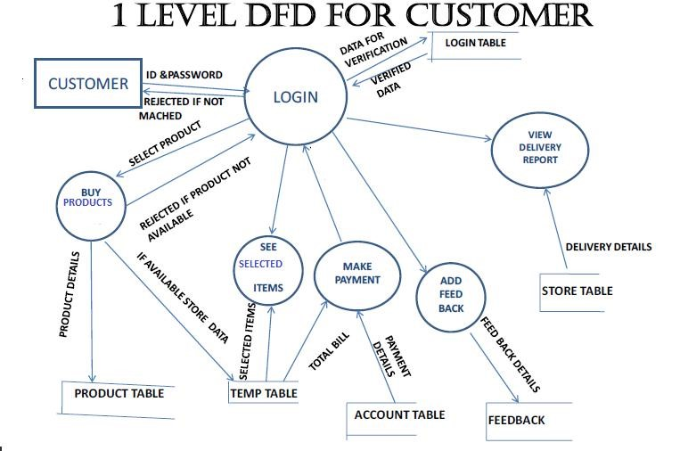

- Technology & Tools Used :

- Front-end Tools:-

- React JS:-

React JS is a JavaScript library used in web development to build interactive elements on websites. React (also known as React.js or ReactJS) is a free and open-source front-end JavaScript library[3] for building user interfaces based on UI components. It is maintained by Meta (formerly Facebook) and a community of individual developers and companies.[4][5][6] React can be used as a base in the development of single-page, mobile, or server-rendered applications with frameworks like Next.js. However, React is only concerned with state management and rendering that state to the DOM, so creating React applications usually requires the use of additional libraries for routing, as well as certain client-side functionality.

- Back-end Tools:-

- MongoDB:-

MongoDB is an open source NoSQL database management program. NoSQL is used as an alternative to traditional relational databases. NoSQL databases are quite useful for working with large sets of distributed data. MongoDB is a tool that can manage document-oriented information, store or retrieve information.

MongoDB provides high availability with replica sets. A replica set consists of two or more copies of the data. Each replica-set member may act in the role of primary or secondary replica at any time. All writes and reads are done on the primary replica by default. Secondary replicas maintain a copy of the data of the primary using built-in replication. When a primary replica fails, the replica set automatically conducts an election process to determine which secondary should become the primary. Secondaries can optionally serve read operations, but that data is only eventually consistent by default.

If the replicated MongoDB deployment only has a single secondary member, a separate daemon called an arbiter must be added to the set. It has a single responsibility, which is to resolve the election of the new primary. As a consequence, an idealized distributed MongoDB deployment requires at least three separate servers, even in the case of just one primary and one secondary.

- Operating System

- Windows 10 & Windows 11

- Additional Software Requirement (Web Browser)

Support Web Browser- Firefox, Mozilla Google Chrome, Microsoft edge.

23

- Hardware Requirement:

System Configuration (CPU, RAM, HDD)

  - Ram- 8GB

  - Storage- 512GB

  - React JS

  - Processor- AMD ryzen 5

- Source Code:

- Categories api:-

import {useState, useEffect} from 'react'
import axios from 'axios'

function CategoriesAPI() {
const [categories, setCategories] = useState([])
const [callback, setCallback] = useState(false)

useEffect(() =>{
const getCategories = async () =>{
const res = await axios.get('/api/category')
setCategories(res.data)
}

getCategories()
},[callback])
return {
categories: [categories, setCategories],
callback: [callback, setCallback]
}

- Product API :-

import {useState, useEffect} from 'react'
import axios from 'axios'

function ProductsAPI() {
const [products, setProducts] = useState([])
const [callback, setCallback] = useState(false)
const [category, setCategory] = useState('')
const [sort, setSort] = useState('')
const [search, setSearch] = useState('')
const [page, setPage] = useState(1)
const [result, setResult] = useState(0)

useEffect(() =>{
const getProducts = async () => {
const res = await axios.get(`/api/products?limit=${page*9}&${category}&${sort}&title[regex]=${search}`)
setProducts(res.data.products)
setResult(res.data.result)
}
getProducts()
},[callback, category, sort, search, page])

return {
products: [products, setProducts],
callback: [callback, setCallback],
category: [category, setCategory],
sort: [sort, setSort],
search: [search, setSearch],
page: [page, setPage],
result: [result, setResult]
}
}

export default ProductsAPI

- USER API :-

import {useState, useEffect} from 'react'
import axios from 'axios'

function UserAPI(token) {
const [isLogged, setIsLogged] = useState(false)
const [isAdmin, setIsAdmin] = useState(false)
const [cart, setCart] = useState([])
const [history, setHistory] = useState([])

useEffect(() =>{
if(token){
const getUser = async () =>{
try {
const res = await axios.get('/user/infor', {
headers: {Authorization: token}
})

setIsLogged(true)
res.data.role === 1 ? setIsAdmin(true) : setIsAdmin(false)

setCart(res.data.cart)

} catch (err) {
alert(err.response.data.msg)
}
}

getUser()

}
},[token])

const addCart = async (product) => {
if(!isLogged) return alert("Please login to continue buying")

const check = cart.every(item =>{
return item._id !== product._id
})

if(check){
setCart([...cart, {...product, quantity: 1}])

await axios.patch('/user/addcart', {cart: [...cart, {...product, quantity: 1}]}, {
headers: {Authorization: token}
})

}else{
alert("This product has been added to cart.")
}
}

return {
isLogged: [isLogged, setIsLogged],
isAdmin: [isAdmin, setIsAdmin],
cart: [cart, setCart],
addCart: addCart,
history: [history, setHistory]
}
}

export default UserAPI

- Back End Code

Categories:-

{"_id":{"$oid":"627d468122234418d082a11e"},"name":"electronic","createdAt":{"$date":{"$numberLong":"1652377217261"}},"updatedAt":{"$date":{"$numberLong":"1652377217261"}},"__v":{"$numberInt":"0"}}

{"_id":{"$oid":"627e0237019bfb3200c85c75"},"name":"Jeans for men","createdAt":{"$date":{"$numberLong":"1652425271213"}},"updatedAt":{"$date":{"$numberLong":"1652425271213"}},"__v":{"$numberInt":"0"}}

{"_id":{"$oid":"627e0432019bfb3200c85c79"},"name":"Grossaries","createdAt":{"$date":{"$numberLong":"1652425778935"}},"updatedAt":{"$date":{"$numberLong":"1652425778935"}},"__v":{"$numberInt":"0"}}

{"_id":{"$oid":"627e72d404230e3a90e08862"},"name":"Soft Drinks","createdAt":{"$date":{"$numberLong":"1652454100480"}},"updatedAt":{"$date":{"$numberLong":"1652454100480"}},"__v":{"$numberInt":"0"}}

{"_id":{"$oid":"627e75ee55810f1ec08fffed"},"name":"Jewellery","createdAt":{"$date":{"$numberLong":"1652454894935"}},"updatedAt":{"$date":{"$numberLong":"1652454894935"}},"__v":{"$numberInt":"0"}}

USERS:-

{"_id":{"$oid":"627d4321e894372674147312"},"role":{"$numberInt":"1"},"cart":[],"name":"simran","email":"simran@gmail.com","password":"$2b$10$qwp1hg2FwLPAZEopquVXL.IFnEN6KAX0zcmRPA9Bb9A1DQ9v31j.q","createdAt":{"$date":{"$numberLong":"1652376353317"}},"updatedAt":{"$date":{"$numberLong":"1652376353317"}},"__v":{"$numberInt":"0"}}

- Snapshots:

- Home:-

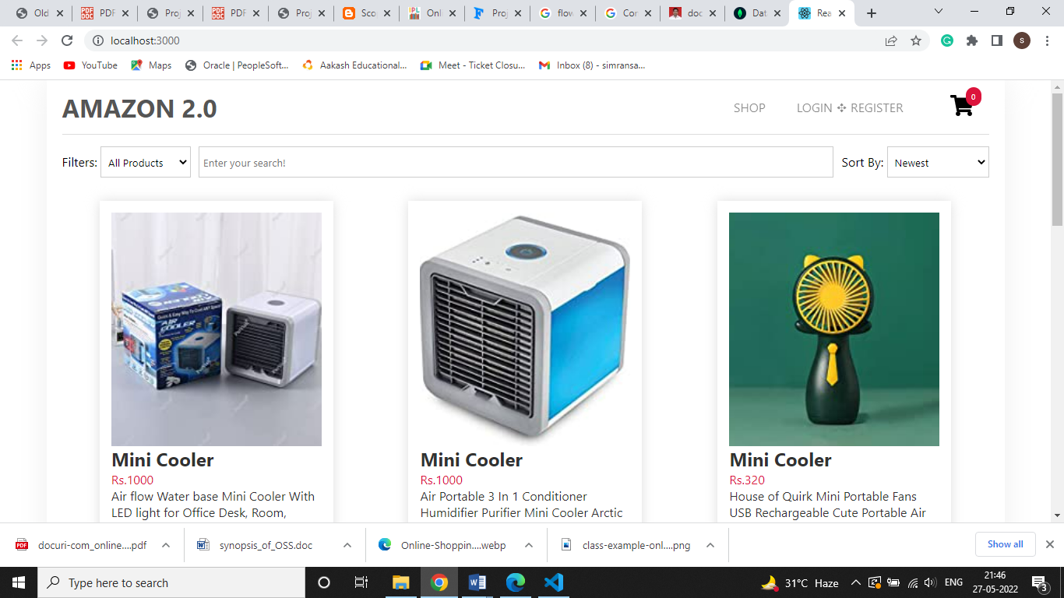

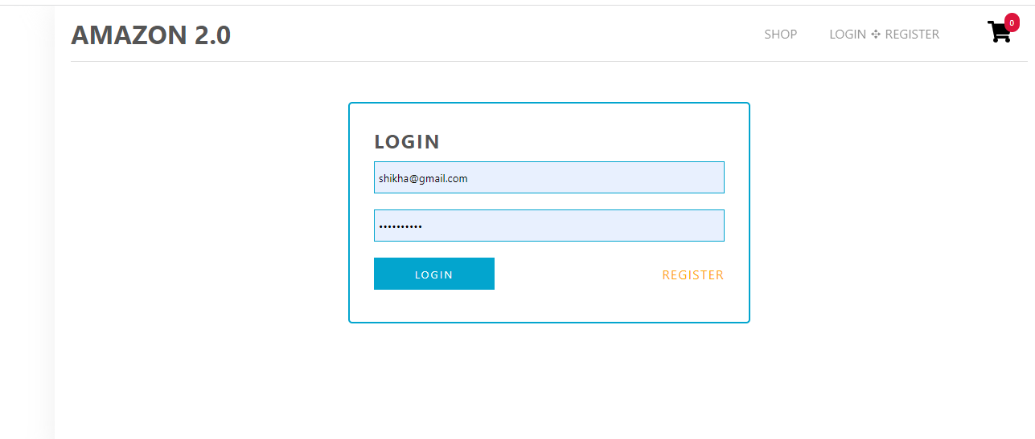

Login Page :-

ADMIN HOME:-

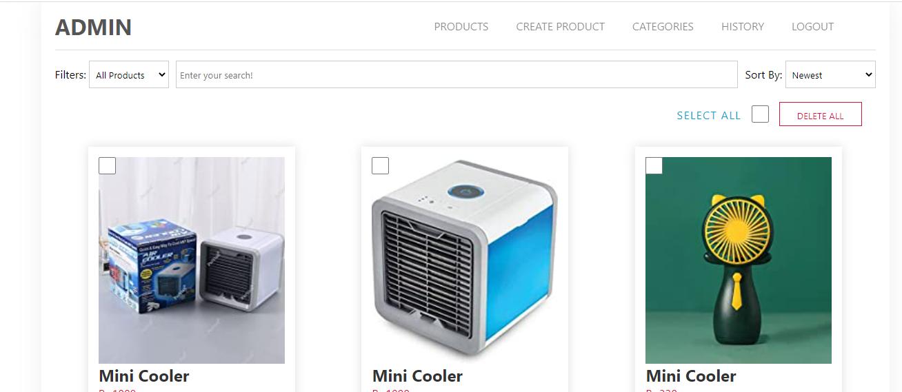
36

Model Evaluation:

Designing interactive systems with graphic user interfaces is an important step in the development of online devices and websites. Online shopping systems and recommender applications have improved in the last decade and they are now widely used all over the world. However, it is important to understand online shoppers needs and preferences and to take them into account. In this regard, several online shopping systems rely on customer preference elicitation while others suggest products based on other customers recommendations. The focus of this paper is the interaction design of a system for Managing Preferences and Constraints (MPC) and Preferences Learning (PL). An evaluation method is utilized to obtain user feedback on how effective the system is and how easy it is to use, compared to other systems. The Volere requirements specification template was used with the six step framework to guide the evaluation.

38
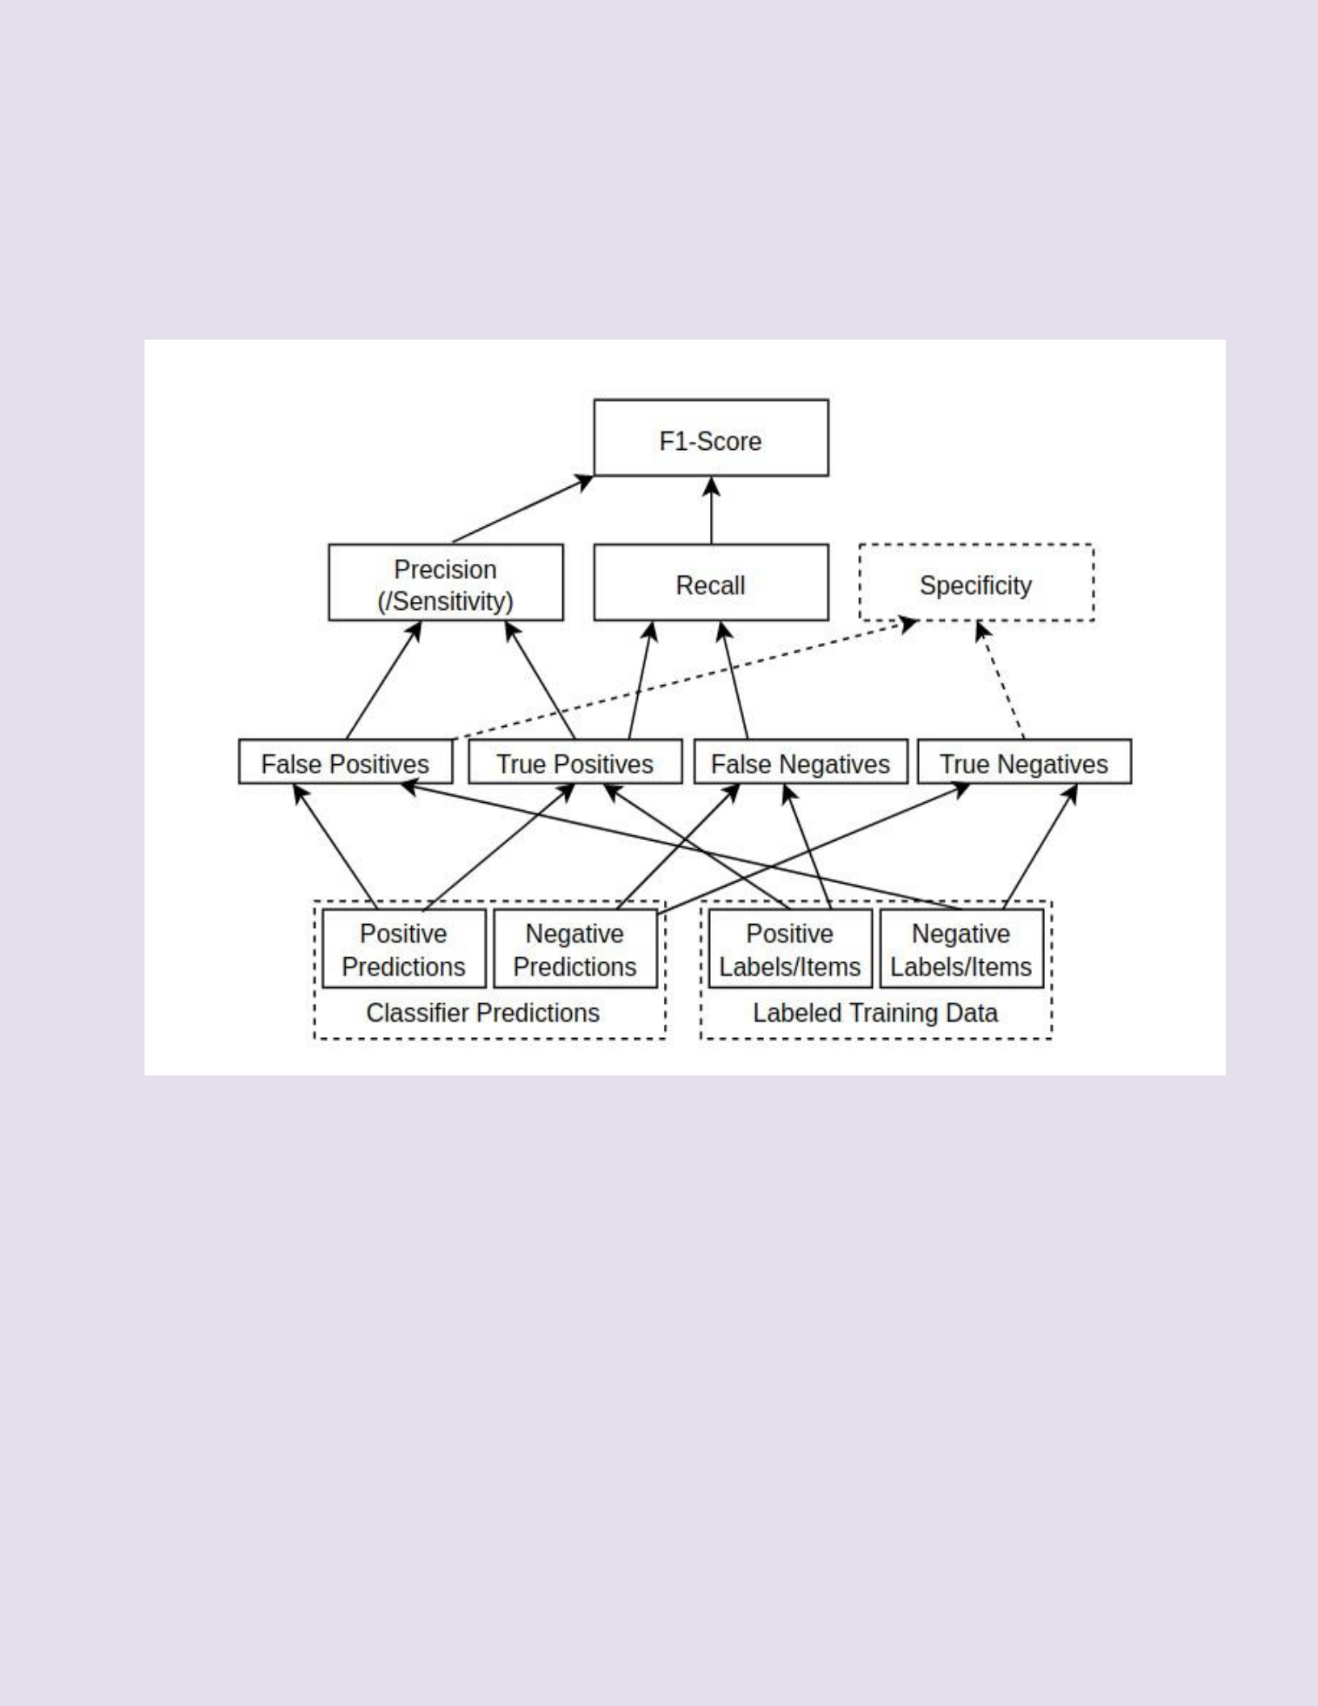
Methods:

Methods used for Model Evaluation are Accuracy, Precision, Recall, FI- score & Support. These relate to getting a finer-grained idea of how well a classifier is doing, as opposed to just looking at overall accuracy.

F1-Score formula

True/False Positives and Negatives

A binary classifier can be viewed as classifying instances as positive or negative:

- Positive: The instance is classified as a member of the class the classifier is trying to identify. For example, a classifier looking for cat photos would classify photos with cats as positive (when correct).

- Negative: The instance is classified as not being a member of the class we are trying to identify. For example, a classifier looking for cat photos should classify photos with dogs (and no cats) as negative.

The basis of precision, recall, and F1-Score comes from the concepts of True

Positive, True Negative, False Positive, and False Negative.

Prediction | Actual value | Type | Explanation
1 | 1 | True Positive | Predicted Positive | and
1 | 1 | True Positive | was Positive
0 | 0 | True Negative | Predicted Negative | and
0 | 0 | True Negative | was Negative
1 | 0 | False Positive | Predicted Positive but
1 | 0 | False Positive | was Negative
0 | 1 | False Negative | Predicted Negative but
0 | 1 | False Negative | was Positive

True Positive (TP)

The following table shows 3 examples of a True Positive (TP). The first row is a generic example, where 1 represents the Positive prediction. The following two rows are examples with labels. Internally, the algorithms would use the 1/0 representation, but I used labels here for a more intuitive understanding.

False Positive (FP)

These False Positives (FP) examples illustrate making wrong predictions, predicting Positive samples for a actual Negative samples. Such failed prediction is called False Positive.

Conclusion:-

Technology has made significant progress over the years to provide consumers a better online shopping experience and will continue to do so for years to come. With the rapid growth of products and brands, people have speculated that online shopping will overtake in-store shopping. While this has been the case in some areas, there is still demand for brick and mortar stores in market areas where the consumer feels more comfortable seeing and touching the product being bought. However, the availability of online shopping has produced a more educated consumer that can shop around with relative ease without having to spend a large amount of time. In exchange, online shopping has opened up doors to many small retailers that would never be in business if they had to incur the high cost of owning a brick and mortar store. At the end, it has been a win-win situation for both consumer and sellers.

49

- Bibliography

- Online Shopping Trends 2013: Most Popular Categories, T. (2014). Online Shopping Trends 2013: Most Popular Categories, Top Purchase Drivers. [online] MarketingProfs. Available at: http://marketingprofs.com/charts/2013/12195/online-shopping-trends-most-popular-categories-top-purchase-drivers [Accessed 12 Sep. 2014].
- Tuttle, B. and Tuttle, B. (2014). Online Shopping: More Popular (Yet Less Satisfying) Than Ever | TIME.com. [online] TIME.com. Available at: http://business.time.com/2013/01/03/online-shopping-more-popular-yet-less-satisfying-than-ever/ [Accessed 12 Sep. 2014]
- The Economic Times, (2005). Online shopping sees 117% growth. [online]Available at: http://articles.economictimes.indiatimes.com/2005-11-04/news/27481115_1_online-shopping-online-consumers-online-sales [Accessed 10 Sep. 2014].
- Online shopping all the rage as teens snub traditional retail outlets. [online] Available at: http://www.theneweconomy.com/business/online-shopping-all-the-rage-as-teens-ditch-traditional-retail-outlets [Accessed 10 Sep. 2014].

50

